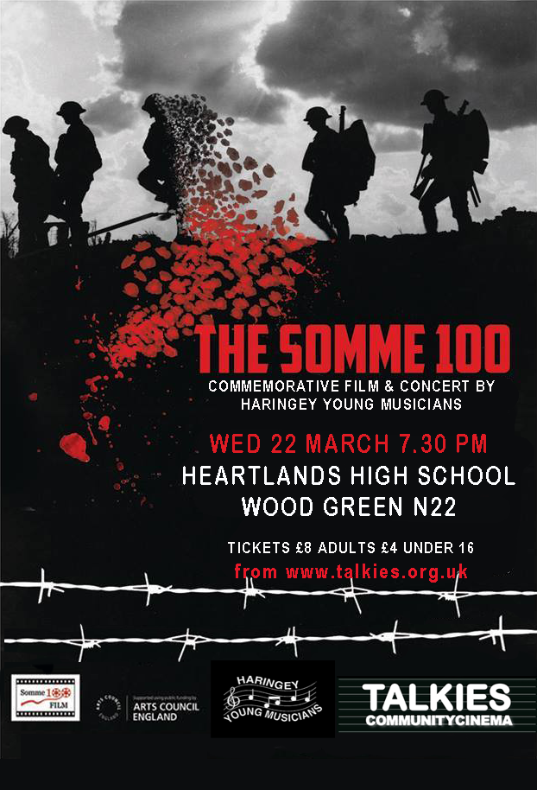


Programme

Carnival Overture Op. 92 Antonin Dvorak

Prelude from Suite Lyrique for solo harp and strings
Harp: Lucy Bannatyne John Rutter

Concerto No. 1 for cello and orchestra
Cello: Naomi Moylan-Torke Dmitri Kabalevsky

INTERVAL

The Battle of the Somme Laura Rossi
The Battle of the Somme remains one of the most successful British films ever made and is the source of the conflict’s most iconic images. Made by British cinematographers Geoffrey Malins and John McDowell, it was not intended to be a feature film, but was compiled into a feature length film by British Topical Committee for War Films. The film gives an unprecedented insight into the realities of trench warfare, controversially including the depiction of dead and wounded soldiers. It shows scenes of the build up to the infantry offensive, including the preliminary bombardment, coverage of the first day of battle (the bloodiest single day in Britain’s military history) and depictions of the small gains and extremely large costs of the attack.
The Imperial War Museum commissioned composer Laura Rossi to create a score for The Battle of the Somme for the 90th anniversary in 2006. The music was recorded and performed live with film by the Philharmonia Orchestra for the premiere at the Queen Elizabeth Hall.

Somme100 FILM is an international project, working with The Imperial War Museums a part of the First World War Centenary Partnership to mark the anniversary of the Battle of the Somme. Talkies Community Cinema, in partnership with Haringey Young Musicians and Heartlands High School are proud to present one of 100 international screenings of the original 1916 film The Battle of the Somme with live orchestral score. Laura Rossi, the composer of the score, will introduce the film and music.

Haringey Young Musicians is the over-arching title for all out-of-school music ensembles organised by Haringey Music & Performing Arts Centre. 22 ensembles meet each week to rehearse a range of different musical styles on a wide variety of instruments from beginner to advanced level. Haringey Young Musicians has an impressive record of ambitious foreign partnerships including projects with schools in China, USA, Argentina, Jamaica, Barbados, France, South Africa, Sweden, Peru and Finland. Members of Haringey Young Musicians live or attend school in the London Borough of Haringey.

Talkies Community Cinema is a not-for-profit volunteer-led organisation which aims to bring communities together through film screenings. Somme 100 is the inaugural event of HERE Film Festival. See the full programme at www.talkies.org.uk.

We are very grateful to the staff, governors and students of Heartlands High School for hosting this special event.

Somme 100 FILM would be very grateful if you could fill in the enclosed feedback form.

Haringey Young Musicians links with the Battle of the Somme

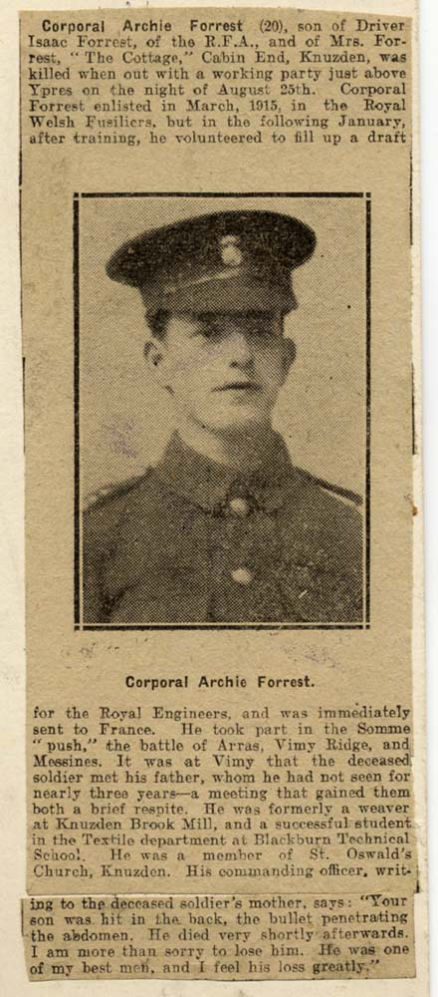

Some of the Young Musicians in the orchestra tonight have family links with World War One and the Battle of the Somme. It is thought provoking to remember that many of the soldiers who took part in World War One were not much older than our Young Musicians here tonight. We are very grateful to the families for sharing these images and stories with us.

Ellie Glynn (French Horn)
Ellie’s great, great uncle Archie fought in the Battle of the Somme. The news of his death was published in the Blackburn Times on September 8th 1917.
Corporal Archie Forrest took part in the Somme ‘push’, the Battle of Arras, the Battle of Vimy Ridge and the Battle of Messines.

Patrick Hegarty-Morrish (Trombone)
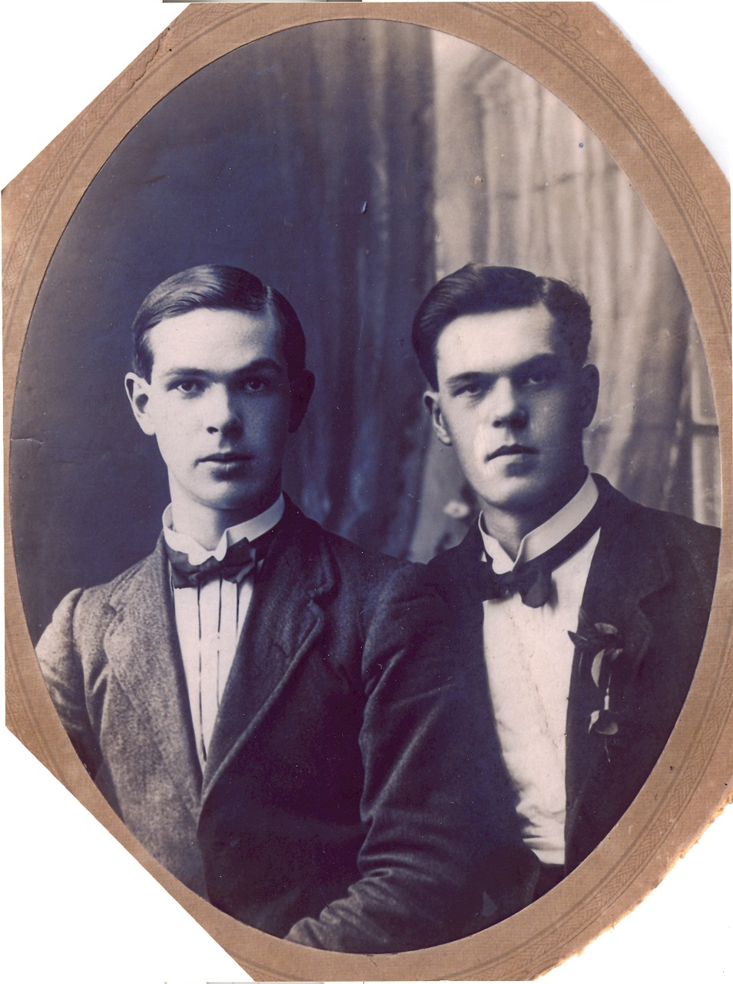
Patrick’s great, great uncles Maurice, Jeremiah and Jack all joined up to fight in WW1.
Maurice fought in Gallipoli and Macedonia. He had been studying Medicine at University College Dublin before he enlisted. Jeremiah fought at the Battle of Passchendaele. Jack fought at numerous battles along the Western Front in the Royal Field Artillery.
Jack received the Military Cross “for great gallantry and devotion to duty on 24th October, 1918, near Ghissignies. A hostile machine gun was holding up the advance and inflicting casualties on infantry, north-east of Ghissignies. He took forward a 6-in. trench mortar to engage it, over some 2,000 yards of open ground under continuous shell fire. He brought his trench mortar into action in the open, and continued firing until the enemy machine gun was silenced.”
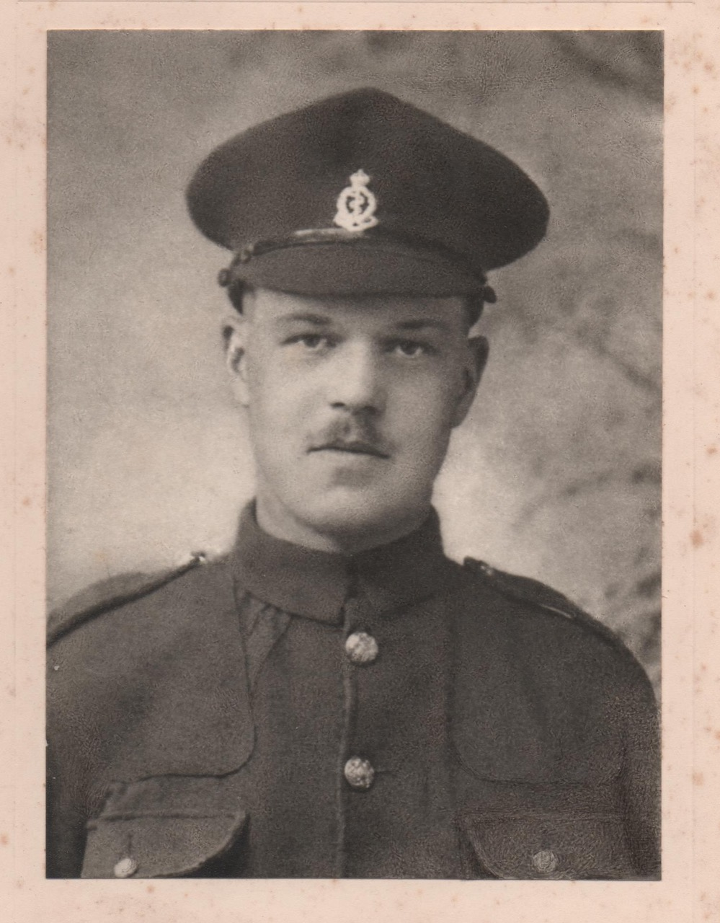
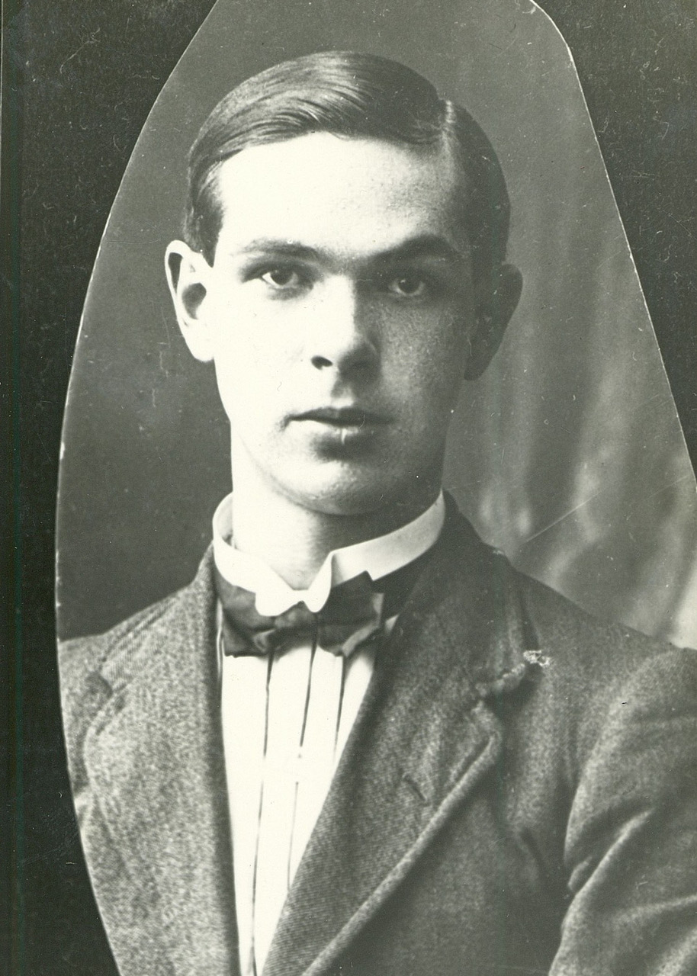
Maurice (left) in his Medical Corps uniform

Jack (right) before going to war in 1915

Emma Robinson (Student at Heartlands High School)
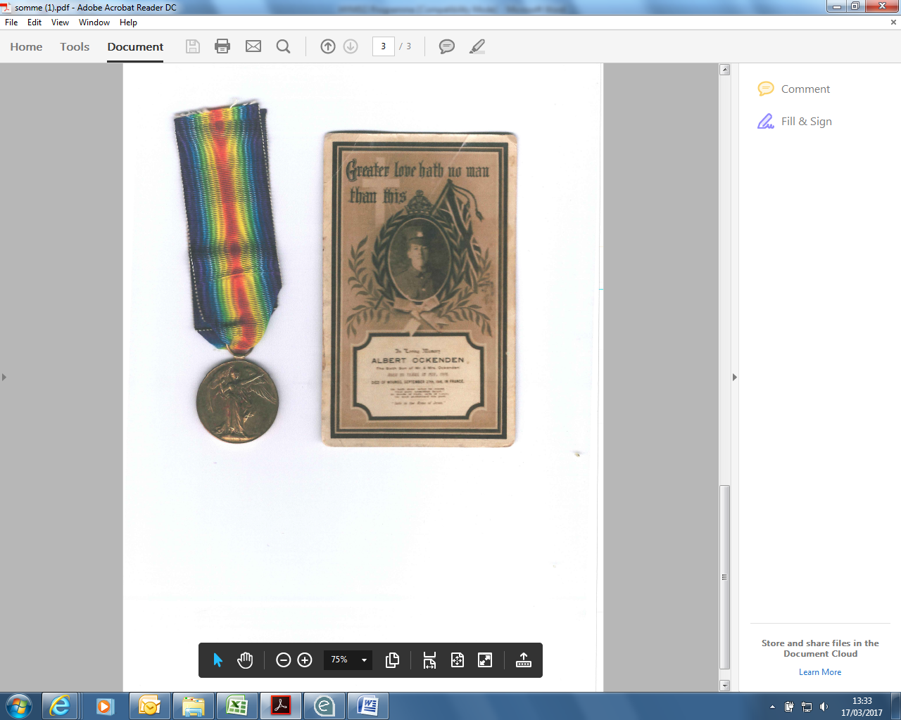
Emma’s great, great uncle Albert Ockenden fought in the Battle of the Somme, as a member of the Yorkshire Regiment. He died of his wounds on September 27th 1916, aged just 19, and is buried in a cemetery at the Somme.

Alice Hathway (Oboe)
Alice’s great, great uncle Charlie was a soldier in the Somme.
Alice says “It’s such a wonderful thing to be taking part in this concert – seeing the film and playing the music shows me what my great, great uncle Charlie had to go through. He can’t have been much older than me when he went out there and it really makes me realise that it was because of people like him that we can enjoy life as we know it.”

“My Mate George”
Haringey Young Musicians Big Band is currently working in collaboration with The Vale School and Northumberland Park Community School on the “My Mate George” project.
“My Mate George” is a devised work combining movement, dance, spoken word and music, inspired by the all too short life of George Lowson (1887-1917) of Tottenham, who died at the Battle of Passchendaele.
In July, a company of performers from the HYM Big Band, The Vale School and Northumberland Park, are taking the project on tour to Ypres, Belgium, and will be performing the work almost 100 years to the day of George’s death at Passchendaele.
The work will be premiered in a concert at Northumberland Park Community School on Thursday 29th June.
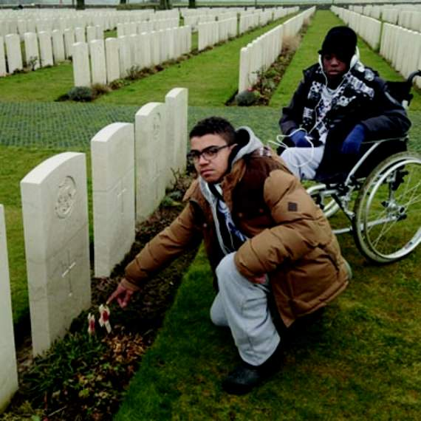

Pupils from the Vale School, who will be coming to Belgium in July, at the grave of George Low

Symphony Orchestra

Leader – Anya Vallentin

1st Violin
Millie-Beth Wright
Agnes Chapman Wills
Andrea Ahern
Rianna Hughes
Arjola Krasniqi
Julia Laskiewicz
Sive Malik
Gabrielle Marcillo-Coronado
Logan Patterson
Imogen Sheppard
Tamzin Sherzad
Stephanie Siran
Sophia Sofianou
Rebekah Allen*

2nd Violin
Luca Seemungal
Lily Bacon Darwin
Annie Do
Raphael Birch
Sasha Brealey
Eleanor Browning
Rachel Chataway-Green
Uma Dell
James Dillon
Iola Elson
Talia Herberg
Sasha Lask
Nancy Levy-Vegh
Freya Mistry
Olivia Siran
Molly Taylor
Ben Woolf
Charlie Higgs*

Viola
Kathleen Archbold
Madeleine Baron
Paloma Charlesworth
Alfred Hellier
Katya Herberg
Jemma Moylan-Torke
Gabriel O’Meara-Head
Georgia Wright
Rob Spriggs*

French Horn
Ellie Glynn
Anna Horrocks
Billy Krish
Isabelle Patterson
Louis Tickner
Anna Drysdale*

Trumpet
Isabel Davidson
Monty Fawcett-Tang
Sam Grigioni-Liney
Joseph Oti

Trombone
Patrick Hegarty Morrish
Jakaya Jenkins
Ishmael Tikly-Young
Sarah Williams*

Tuba
Lucas Kennedy

Percussion
Kevin Brovina
Joseph Browning
Joe Doyland
Eva Laverty
Noah Stoneman
Rebecca McChrystal*

Harp
Lucy Bannatyne
Andrea Figaro
Anyi Le Quesne

*Denotes tutor

Cello
Kristian Baird
Ben Dawson
Raphael Herberg
Casper Herberg
Jacques Jervis
Erin Kelly
Eden Maddix Odeniyi
Zohra Malik
Matthew Price
Christopher Williams
Thomas Gregory*

Double Bass
Ben Selig
Ned Elser
Geraldine Warner*

Flute/Piccolo
Amy Davis
Grace Henry
Miayla Marcus
Gareth Morgan
Nick Lacey*

Oboe/Cor Anglais
Georgia Fernando
Alice Hathway
Aliyah Ratcliffe
Clare Hoskins*

Clarinet
Anouk Cavendish
Maya Charlesworth
Rhiannon Morgan
Jamie Ross
Chris Stripp*

Bassoon
Eva McNeill
Naomi Moylan-Torke
Rebecca Nicolson*

