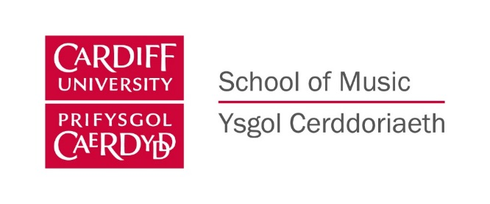
Cardiff University School of Music: Press release

Somme100 Film – Sunday 13 November 2016, 2 pm St David’s Hall Cardiff

Somme100 Film is an international project, working with the Imperial War Museums (IWM) as part of the First World War Centenary Partnership to mark the anniversary of the Battle of the Somme. Bringing together 100 live orchestral performances of the iconic 1916 film The Battle of the Somme with composer Laura Rossi’s acclaimed score, commissioned by the IWM. Sunday’s screening at St David’s Hall with Cardiff University Symphony Orchestra playing Laura’s score is the only performance of this project in Wales.

About the film
Smiling awkwardly at the new-fangled cameras, troops move towards the Front in the Great War. Their actions are far removed from the swagger and march of the war films, but then this is real. The Battle of the Somme remains one of the most successful British films ever made. It is estimated over 20 million tickets were sold in Great Britain in the first two months of release and the film was distributed world-wide to demonstrate to allies and neutrals Britain’s commitment to the First World War. It is estimated that over half the population of the UK watched The Battle of the Somme (a figure not matched until the release of Star Wars in 1977).

It is the source of many of that conflict’s most iconic images. It was made by British official cinematographers Geoffrey Malins and John McDowell. Though it was not intended as a feature film, once the volume and quality of their footage had been seen in London, the British Topical Committee for War Films decided to compile a feature length film.

The Battle of the Somme gave its 1916 audience an unprecedented insight into the realities of trench warfare, controversially including the depiction of dead and wounded soldiers. It shows scenes of the build-up to the infantry offensive including the massive preliminary bombardment, coverage of the first day of the battle (the bloodiest single day in Britain’s military history) and depictions of the small gains and massive costs of the attack. The film’s importance was recognised in 2005 by its formal inscription in the UNESCO ‘Memory of the World’ register – the first British document of any kind to be included, and one of the few films that has so far been added to the register.

About the Music
Laura Rossi’s score was commissioned to mark the 90th anniversary of The Battle of the Somme as a soundtrack for the digitally restored film. When embarking on her research on the film and the battle, Laura discovered her great uncle, Fred Ainge, (whom she knew as he survived the war) was a stretcher-bearer attached to the 29th Division on 1 July 1916. In preparation for composing the score she visited the Somme Battlefields, using Fred’s diaries to locate the areas in which he served. The re-mastered film was screened for the 90th anniversary of the Battle to a full house at the Queen Elizabeth Hall with the premiere of Laura’s score, performed by the Philharmonia Orchestra and received a five star review in The Times.

Notes to Editors:
For press information and images, contact: somme100film@gmail.com
For Cardiff University School of Music, contact: Helen Conway 02920875939, email: conwayh@cardiff.ac.uk
More info: www.somme100film.com
Laura Rossi. Dr Toby Haggith (IWM Senior Curator) and Mark Eager (Cardiff University Symphony Orchestra, conductor) are available for interviews.
To contact Laura Rossi – tel: 07765293822, email: laura@laurarossi.com
To contact Mark Eager email: mark@markeager.com

Tickets £8, £10 for two, various concessions are also available from St David’s Hall box office in person (see St David’s Hall website for opening hours), online at http://www.stdavidshallcardiff.co.uk/whats-on or call 02920878444

